OGDEN’S ENCYCLOPEDIA OF RADIO HORROR—“Y” Copyright © 2010 Vanished Voices OTR
`

Y 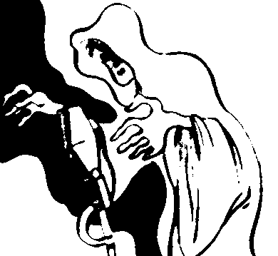

YOURS TRULY, JACK THE RIPPER

MOLLE MYSTERY THEATRE (WEAF, NEW YORK—NBC)
[Tuesday—
February 27, 1945 “Yours Truly, Jack the Ripper”
[CINCINNATI ENQUIRER: “…A bloody trail of murder, beginning in London more than half a century ago, is brought to a final half??? in present-day Chicago in Robert Block’s [sic] ‘Yours Truly, Jack the Ripper’…”]

